1 схема

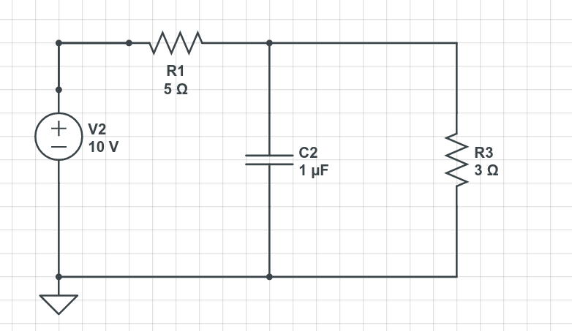

circuit.subcircuit(LineCircuit('Line'))
circuit.V(1, 1, circuit.gnd, 100@u_V)
circuit.R(1, 1, 2, 1@u_Ω)
circuit.C(1, 2, circuit.gnd, 0.001@u_F)
circuit.X(1, 'Line', 2, 3)
circuit.R(3, 3, circuit.gnd, 2@u_Ohm)

